Behind the mirror

In a flat mirror you can see the reflection of an object.
The reflection looks as if it is behind the mirror.

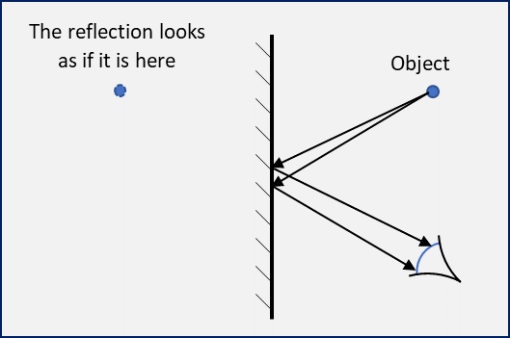

Why does the reflection look as if it is behind the mirror?
Put a tick (✓) in the box next to the best answer.
A | The object’s image bounces (reflects) off the mirror
B | The object’s image reflects off the mirror at an equal angle
C | Light appears to come from an object behind the mirror
D | The mirror makes an image of what is in front of it

Physics > Big idea PSL: Sound, light and waves > Topic PSL3: Making images > Key concept PSL3.1: The ray model of light to explain images
Diagnostic question
Behind the mirror

Overview
Learning focus: | A plane mirror reflects light rays from each point of an object so they appear to come from distinct points behind the mirror and the reflection is seen as if it were behind the mirror.
Observable learning outcome: | Explain why the reflection of an object in a plane mirror appears to be behind the mirror.
Question type: | Simple multiple choice
Key words: | Reflection, plane mirror, image

What does the research say?
Unlike pinholes, plane mirrors do not form (real) images that can be projected onto a screen. Notwithstanding, many students think that a mirror forms an image that can be viewed as if the mirror were a photograph (Ceuppens et al., 2018; Galili and Hazan, 2000). About a quarter of 13- to 15-year olds in a study by Fetherstonhaugh and Treagust (1990) thought that light stays on a mirror during reflection. Before teaching, Galili and Hazan (2000) found that about half of students thought that mirrors duplicate (reflect) objects by creating an image. This misunderstanding fell significantly after teaching, but over a quarter of students aged 14-16 persisted in thinking that the image travels to a mirror and bounces off it, and any obstacles between the object and the mirror prevent the image from reaching the mirror.
A challenge to understanding how an object is seen in a plane mirror is the fact that the observer is an inherent part of the optical system (Galili and Hazan, 2000; Andreou and Raftopoulos, 2011). It is perhaps helpful to discuss the reflection of an object in a plane mirror and the formation of an image by the eye looking at the reflection.
Ways to use this question
Students should complete the question individually. This could be a pencil and paper exercise, or you could use an electronic ‘voting system’ or mini white boards and the PowerPoint presentation.
The answers to the question will show you whether students understood the concept sufficiently well to apply it correctly.
If there is a range of answers, you may choose to respond through structured class discussion. Ask one student to explain why they gave the answer they did; ask another student to explain why they agree with them; ask another to explain why they disagree, and so on. This sort of discussion gives students the opportunity to explore their thinking and for you to really understand their learning needs.

Differentiation
You may choose to read the questions to the class, so that everyone can focus on the science. In some situations it may be more appropriate for a teaching assistant to read for one or two students.
Expected answers
Answer C: Light appears to come from an object behind the mirror.
How to respond - what next?
The idea expressed in answers A and B, that light rays bring an image to a mirror and is then reflected at the angle equal to the angle of incidence, has been found to develop during the teaching of optics. Galili and Hazan (2000) found that teaching students aged 14-16 increased the prevalence of those holding this misunderstanding from about zero to almost half.
By contrast, those holding the misunderstanding that a mirror duplicates an object by creating its image fell from about half of students before teaching to about zero afterwards.
If students have misunderstandings about why the reflection appears to be behind the mirror, it can help to use structured discussion to guide the class through how we judge distance. Looking at an object, each eye looks from a slightly different angle to the other. The size of the angle is translated by the brain into a distance. Young babies learn this by trial and error as they reach out for objects. If when we look into a mirror light enters our eyes at the same angle as it would from an object that is behind the mirror, then that is where the object appears to be.
An informative exercise students can do in pairs is for one of them to hold a pencil horizontally by its tip and the second student is challenged to touch (quickly) the other end of the pencil with a fingertip. When carried out with two eyes open, the second student rarely misses. With one eye covered up the task is much more problematic.
When looking into a plane mirror students can observe that the closer they are to a mirror, the closer their reflection also appears to be to the mirror. The following BEST ‘response activity’ demonstrates to students that these distances are identical:
- Response activity: Reflection hunt
Acknowledgments
Developed by Peter Fairhurst (UYSEG).
Images: Peter Fairhurst (UYSEG).
References
Andreou, C. and Raftopoulos, A. (2011). Lessons from the history of the concept of the ray for teaching geometric optics. Science and Education, 20, 1007-1037.
Ceuppens, S., et al. (2018). Tackling misconceptions in geometric optics. Physics Education, 53, 10.
Fethersonhough, T. and Treagust, D. (1990). Students' understanding of light and its properties following a teaching strategy to engender conceptual change. Annual meeting of the American Educational Research Association. Boston.
Galili, I. and Hazan, A. (2000). Learners' knowledge in optics: interpretation, structure and analysis. International Journal of Science Education, 22(1), 57-88.

